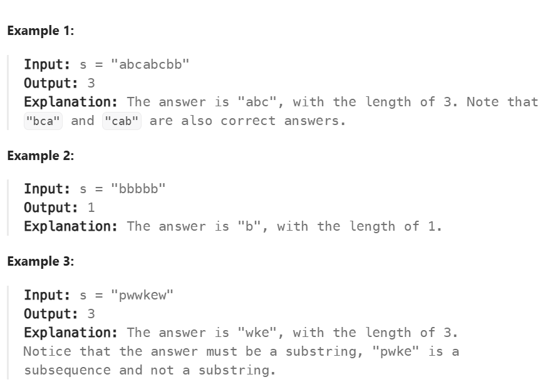

BRUTE FORCE: TC:O(N^2) , SC: O(N)
->generate all substrings
class Solution {
public int lengthOfLongestSubstring(String s) {
int len = 0;
for(int i = 0 ; i< s.length();i++)
{ int currlen = 1;
HashSet<Character> hs = new HashSet();
hs.add(s.charAt(i));
for(int j = i+1;j<s.length();j++)
{
if(hs.contains(s.charAt(j)))
break;
hs.add(s.charAt(j));
currlen++;
}
len = Math.max(len , currlen);
}
return len;
}
}

OPTIMAL: TC:O(N) , SC:O(N)
->if the element is in the hashmap update the left pointer else move the right
class Solution {
public int lengthOfLongestSubstring(String s) {
int l = 0, r = 0, maxLen = 0;
HashMap<Character, Integer> hm = new HashMap<>();
while (r < s.length()) {
char ch = s.charAt(r);
if (hm.containsKey(ch)) {
l = Math.max(l, hm.get(ch) + 1);
}
hm.put(ch, r);
maxLen = Math.max(maxLen, r - l + 1);
r++;
}
return maxLen;
}
}

